Dear Professor.
I have just implemented minimax (with alpha beta pruning) and expectimax algorithm then apply it to some simple cases to compare them.

In the case below, the ghosts randomly move.
With depth 4, minimax algorithm always lose because he assumes the worst case that the blue ghost will go to eat him. So the best choice for him is go to suicide to the orange ghost so the game is end in the fastest way (because he get -1 score after each move).

But with expectimax algorithm, he balances between the dead and the score after get the food. So he will go toward to the blue ghost. And because the ghost is random, he has 50% to win this game.

This is the simple case to help me understand the differences between 2 algorithms.
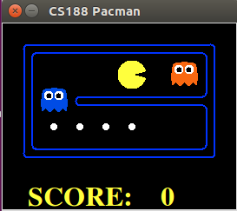

---------------------------------------------------------------

Back to the mini map of Pacman,
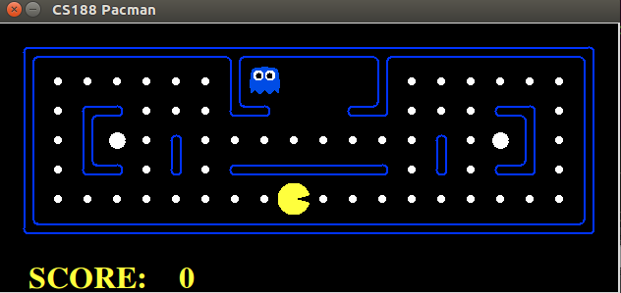

In this case, I used minimax algorithm with depth 2 to solve this problem.
I used this evaluation function to calculate the state score:

currentScore + 0.01*distanceToGhost - 0.2*distanceToFood - length(foodList) - length(powerFood)
With distance is the manhattan distance to the closest object.

Although that evaluation can solve the problem, sometimes it stuck like this
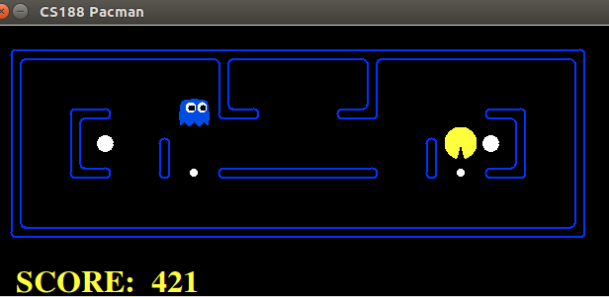
And he has to wait the ghost comes near him so that he can get out of this situation.
I think he got stuck because my evaluation is calculated base on the distance to the closest food so that if he eat the in front of food, the distanceToFood will increase dramatically. So he has to wait the ghost comes near to him so that distanceToGhost will affect his behavior.

By the way, this is the result after 10 games,
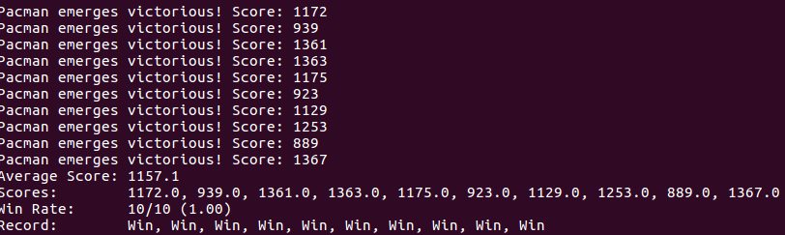
The score under 1000 is that the pacman stuck in the above problem.

Next, I think I have to change the evaluation to make it moves better and try to apply Q-learning to the original version.

Yours sincerely,
Danh Vo.

